Microbiology Project Name: _______________________
Microbes & Infectious Diseases Block: _______
Due: Feb 9 & 10

Each student will be required to research a pathogen and create a wanted poster using the template provided.

Criteria: Each project should include all of the following material:

(Check when you’ve completed)

_____ 1. Have your disease approved by your teacher: __________

_____ 2. Photo: In color: may be printed or hand drawn. You could print it in black and white and then add color with marker or colored pencil. Microscopic view or gram stain.
_____ 3. Written Description of pathogen (IN YOUR OWN WORDS)
_____ 4. Organism’s Modus Operandi or M.O. (Police jargon for habits or what the organism is known for)
_____ 5. Most Common Victims to prey upon
_____ 6. Hide-Out of the culprit (where it’s most likely/commonly found)
_____ 7. Most Common Symptoms done to the victim
_____ 8. Threat Rating: Is this pathogen considered armed and dangerous? (Rate the degree of damage caused)
_____ 9. Number of Victims
_____ 10. Prevention or Treatment: Most effective weapon against the germ
_____ 11. Identifying Characteristics:
_____ 12. ALL NOTES AND RESEARCH MUST BE SHARED ON A GOOGLE DOC!

LABEL all the parts of your project. Use the 10 labels above that are in bold and underlined.

Resources: Online resources for your pathogen

- http://www.cdc.gov/ncidod/dbmd/diseaseinfo/default.htm
- http://www.niaid.nih.gov/topics/pages/default.aspx
- http://www.niaid.nih.gov/topics/biodefenserelated/biodefense/pages/cata.aspx
- You may use other resources/websites to complete your research.

Hints and Suggestions:
- DO NOT copy your work; put everything in your own words!!!!
- Turn in your project on time.
- BE CREATIVE. If you add additional information and go over and beyond the criteria it is possible to receive bonus points!
- Use the rubric below to help guide you.

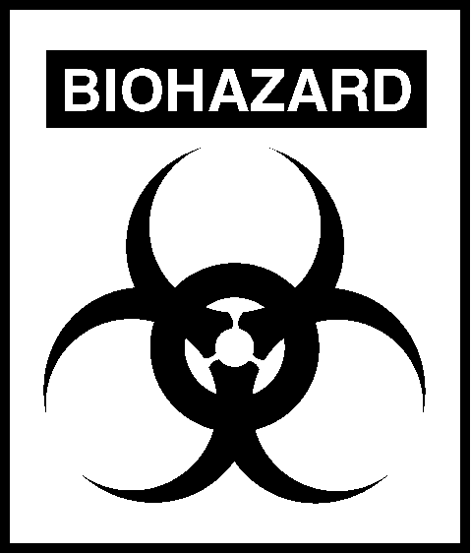

Microbiology Project Rubric
Microbes & Infectious Diseases
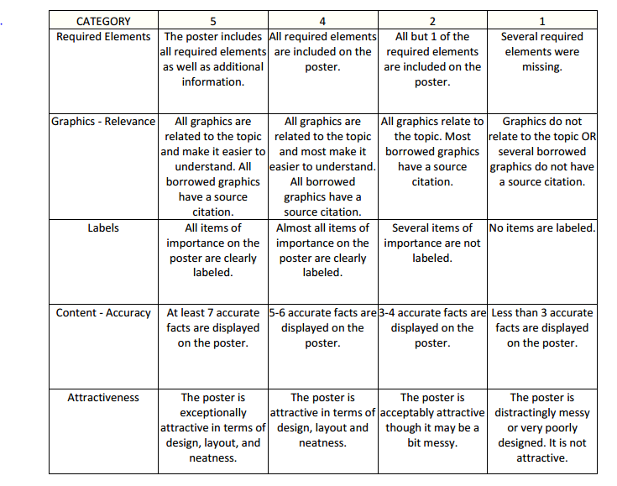

Viral | Bacterial | Parasite | Fungal | Zoonotic
Viral Meningitis | Tuberculosis | Malaria | Thrush | Hantavirus
Conjunctivitis | Cholera | Echinococcosis | Valley Fever | Bovine Spongiform Encephalopathy
Measles | Typhoid Fever | Leishmaniasis | Blastomycosis | Avian Flu
Polio | Leprosy | Schistosomiasis | Madura foot | Swine Flu
Rabies | Tetanus | African Sleeping Sickness | Cryptococcosis | Marburg Fever
Norovirus | Botulism | Trichinellosis | Aspergillosis | Yellow Fever
SARS | Bacterial Meningitis | Cystoisosporiasis | Zygomycosis | Dengue Fever
Hepatitis E | Clostridial Myonecrosis | Toxoplasmosis | Tinea Pedis | Cellulitis
Mononucleosis | MRSA | Giardiasis | Tinea Capitis | Lyme Disease
Mumps | Salmonella | Guinea Worm | Ringworm | Tularemia
Chicken Pox | Diptheria | Tungiasis |  | Rift Valley Fever
Shingles | Typhus Fever | Cryptospiridiosis
HIV | Bubonic Plague | Hookworm
Lassa Fever | Pneumonia | Scabies
West Nile Virus | Kawasaki disease | African Trypanosomiasis
Machupo Virus | Scarlet Fever | Changas Disease
Nipah Virus | Pertussis | Acanthamoeba Keratitis
Coxsackie Virus | Necrotizing Fasciitis | Paragronimiasis
B Virus |  | Naegleria Fowleri
Ebola Virus

